
National
University
of
Computer
and
Emerging
Sciences
Chiniot-Faisalabad
Campus
CL2001 – Data Structures - Lab
Lab 8
“Recursion & Basics of Tree’s”
Fall 2024
Maximum Marks: 100 Due Date: 11 October 2024
Submitted By
Name: | Talha Abdullah
Student ID: | 22F-3194
Section: | BAI-3A
Submitted To
Muhammad Yousaf
Lecturer – AI & Data Science Department
Submission Date
11 October 2024

Problem 1

Source Code
#include<iostream>
#include<string>
using namespace std;

void copyStr(string s1, string& s2, int index);
int magicNumber(int arr[], int size);

int main() {
string s1, s2;
int size = 0, output = 0, val = 0, index = 0;
int arr[100];

while (true) {
cout << "-----------Menu--------------" << endl;
cout << "1. to Copy the string" << endl;
cout << "2. to magic the numbers" << endl;
cout << "0. to exit the program" << endl;
cout << endl;
cout << "Enter a value to visit the menu: ";
cin >> val;
cin.ignore();

switch (val)
{
case 1:
cout << "Enter a string: ";
getline(cin, s1);

s2 = "";
index = s1.length();
copyStr(s1, s2, index - 1);

cout << "\nThe output of the string is: " << s2 << endl;
break;
case 2:
cout << "Enter the size of an array: ";
cin >> size;

cout << "Enter " << size << " elements: ";
for (int i = 0; i < size; i++) {
cin >> arr[i];
}

output = magicNumber(arr, size);

cout << "\nThe output is: " << output << endl;
break;
case 0:
return 0;
default:
cout << "Invalid choice! Try again.\n";
break;
}
}

return 0;
}

void copyStr(string s1, string& s2, int index) {
if (index < 0) {
return;
}
else {
if (isupper(s1[index])) {
s2 += s1[index];
}
copyStr(s1, s2, index - 1);
}
}

int magicNumber(int arr[], int size) {
if (size < 0) {
return 0;
}
else {
if (size % 2 == 0) {
return arr[size] * 9 + magicNumber(arr, size - 1);
}
else {
return arr[size] * 99 + magicNumber(arr, size - 1);
}
}
}

Screenshot
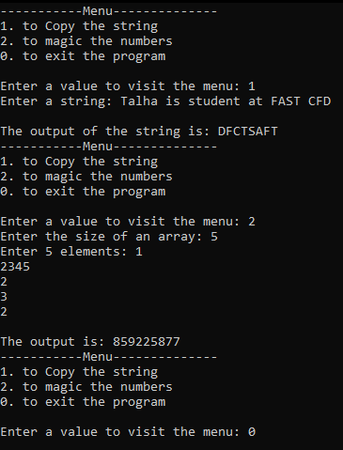

Problem 4

Screenshot
(A)
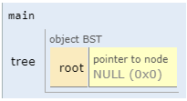
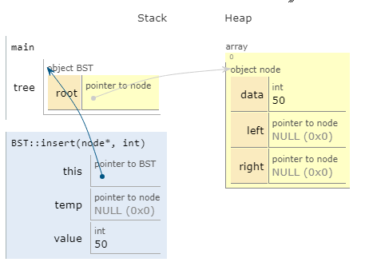
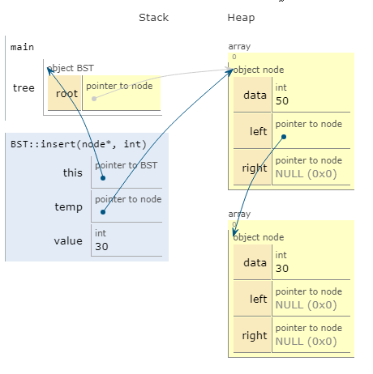
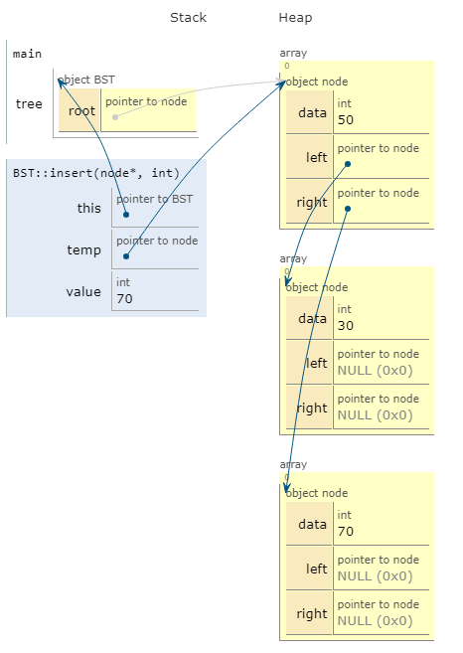
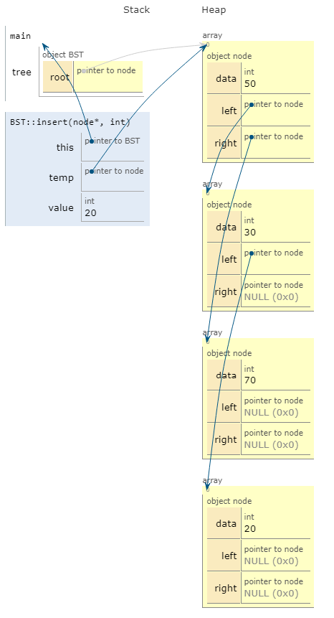
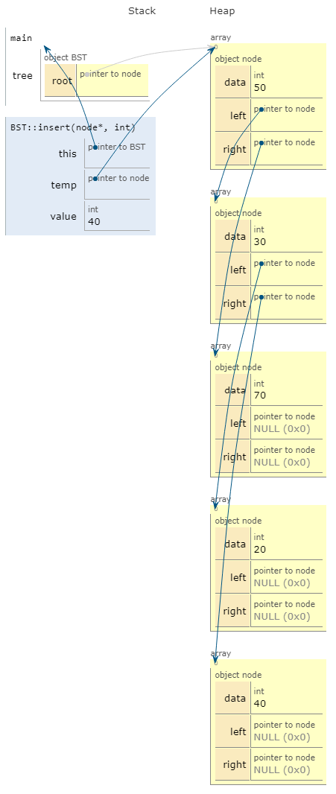
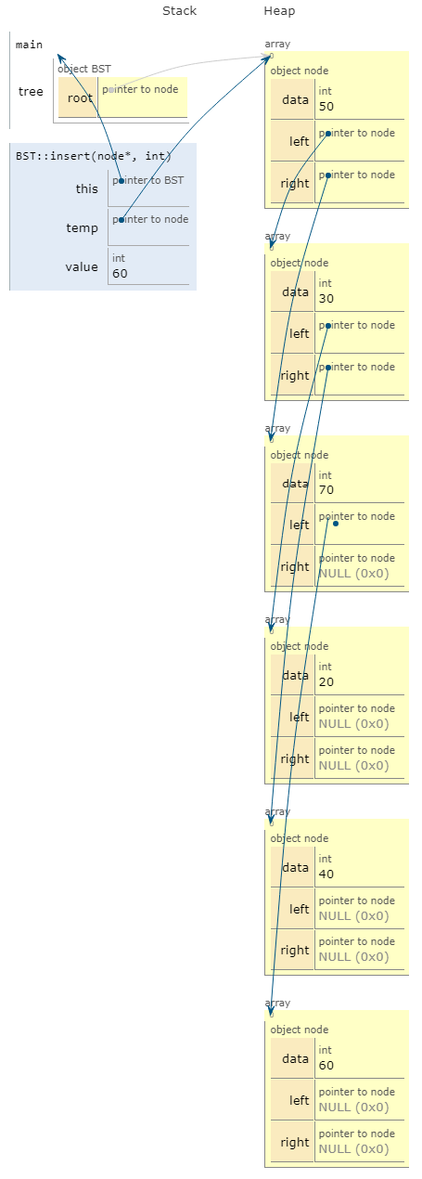
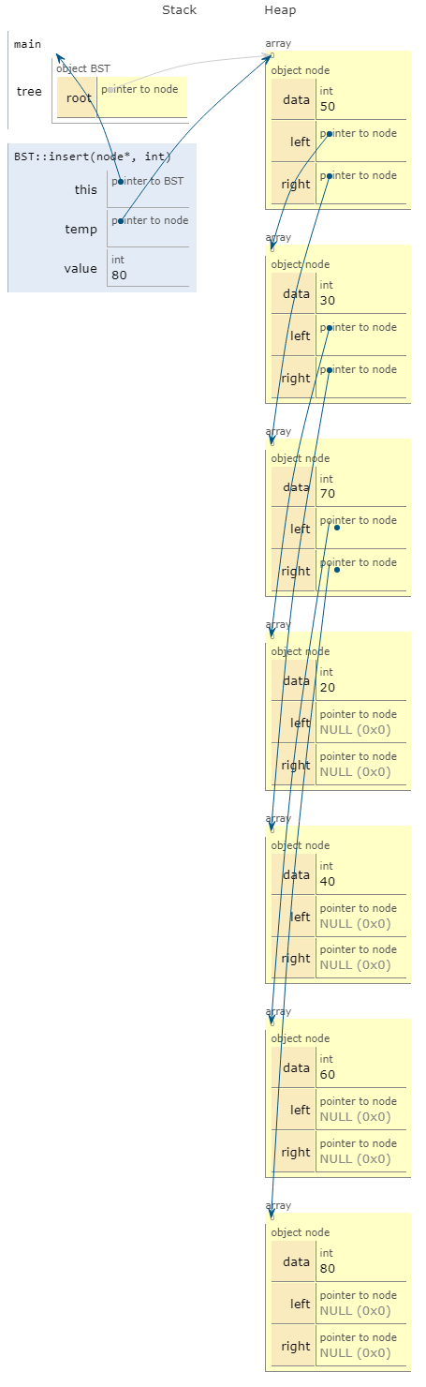
(B)

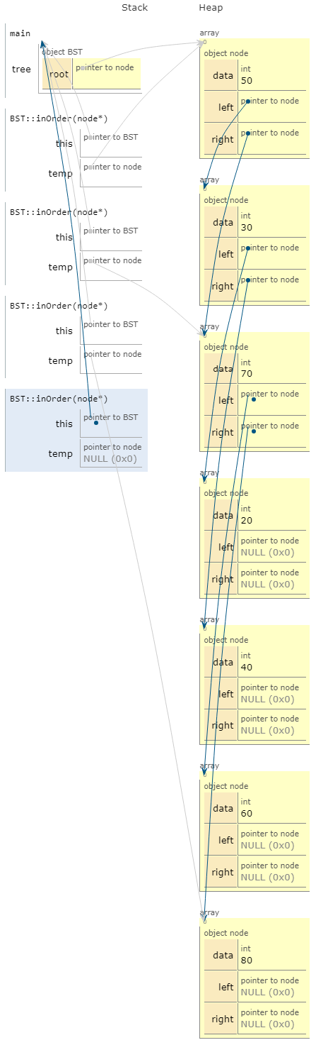

Problem 3

Formula solution
(1)
Node=127
H=log2(127+1)-1
H=log2(128)-1
H=7-1
H=6
(2)
H=5
Leafnode=12
Inter node
I=l-1
L=12-1
L=11
Number of node
N=I+L
N=11+12
N=23
(3)
H=6
Inter node= 2^n-1 = 2^6-1 = 63
Leaf Node = 2^h = 2^6 = 64
Total node = 2^n+1 -1 = 2^7 -1 = 127
(4)
N=512
H=log2(n+!-1)
H=log2(512)-1
H=9-1
H=8
(5)

Problem 2

Source Code
#include <iostream>
using namespace std;

class node
{
public:
int data;
node* left;
node* right;

node(int val)
{
data = val;
left = right = nullptr;
}
};

class BST
{
public:
node* root;

BST() : root(nullptr) {}

void insert(node*& temp, int value)
{
if (temp == nullptr) {
temp = new node(value);
return;
}
if (value < temp->data)
{
insert(temp->left, value);
}
else if (value > temp->data)
{
insert(temp->right, value);
}
}

bool find(node* temp, int key)
{
while (temp != nullptr)
{
if (temp->data == key)
{
return true;
}
if (key < temp->data)
{
temp = temp->left;
}
else
{
temp = temp->right;
}
}
return false;
}
};

int main()
{
BST tree;
tree.insert(tree.root, 50);
tree.insert(tree.root, 30);
tree.insert(tree.root, 70);
tree.insert(tree.root, 20);
tree.insert(tree.root, 40);
tree.insert(tree.root, 60);
tree.insert(tree.root, 80);
tree.insert(tree.root, 12);
int val;
cout << "Enter value to find: ";
cin >> val;
bool check = tree.find(tree.root, val);
if (check)
cout << val << " is found in BST " << endl;
else
cout << val << " is not found in BST " << endl;
cout << endl;
system("pause");
return 0;
}

Screenshot
